|  |  |
| --- | --- |
|  |  |
|  | Foundation Activity 7 Ohm’s Law |

Rock-Slide Analogy of Electricty

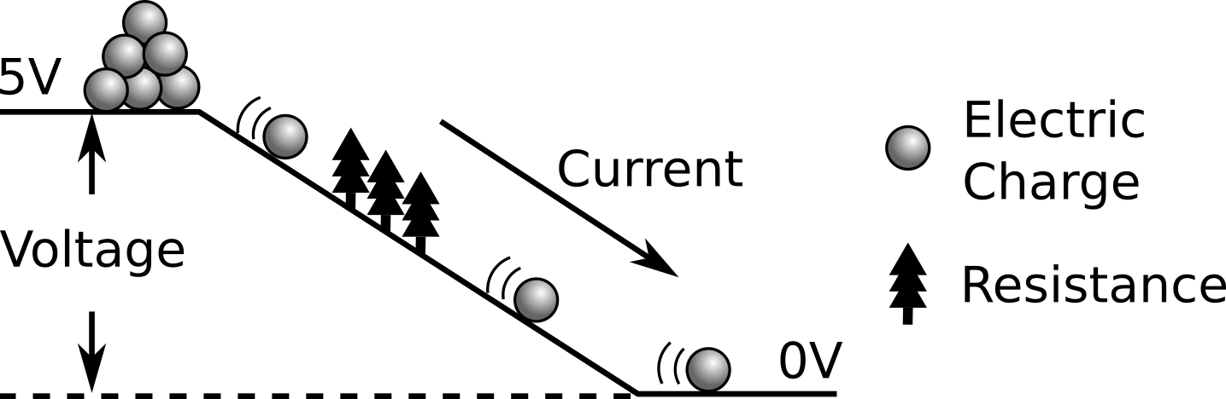

|  |  |  |  |
| --- | --- | --- | --- |
| Rock-slide Symbol | Electrical Property | Unit | Equation Symbol |
| Height of the Hill | Voltage | Volts [V] | V |
| Trees | Resistance | Ohms [Ω] | R |
| Moving Rocks | Current | Amps [A] | I |

Ohm’s Law

What happens to current when we increase the voltage? **It increases.**

What happens to current when we increase the resistance? **It decreases.**

|  |  |
| --- | --- |
| Ohm’s Law describes this relationship between resistance (R), the voltage (V) across the resistance, and the current (I) through the resistance. As long as we know two of those three, we can find the third by rearranging Ohm’s Law. | $$Ohm^{'}s Law:$$ $$I=\frac{V}{R}$$ |
| To help with this, we can imagine the equation as a triangle. By covering the variable we’re looking for, the equation using the remaining two variables is left. If they are stacked on top of each other, we divide; if they are side-by-side, we multiply. | C:\Users\Harryp\MEGA\Surface Pro 2\Nepal\Himalayan Makers Guild\Activities\Foundation Activities\FA7 - Ohm's Law and Resistor Values\images\ohms.png |

Resistor Example

|  |  |  |
| --- | --- | --- |
| V = 5 V  I = 0.1 A  What is the resistance, R? |  | |
| We want to calculate R, so we rearrange the equation to be: | | C:\Users\Harryp\MEGA\Surface Pro 2\Nepal\Himalayan Makers Guild\Activities\Foundation Activities\FA7 - Ohm's Law and Resistor Values\images\ohms.png |

LED Circuit Example

|  |  |  |
| --- | --- | --- |
| The maximum current for the LED is 20 mA (0.02A), so what resistor value should we choose if our supply voltage is 5V?  The total voltage from the battery (5V) is dropped across both the resistor AND the LED, since they are wired in series. $$5V=V_{R}+V_{LED}$$ When the white LED is on, it has a voltage drop of 3V. This leaves only 2V dropping across the resistor. We use the 2V dropped across the resistor when calculating the resistor value. | | C:\Users\Harryp\MEGA\Surface Pro 2\Nepal\Himalayan Makers Guild\Activities\Foundation Activities\FA7 - Ohm's Law and Resistor Values\images\5vLED1.png |
| We want to calculate R, so we rearrange Ohm’s Law to be: | C:\Users\Harryp\MEGA\Surface Pro 2\Nepal\Himalayan Makers Guild\Activities\Foundation Activities\FA7 - Ohm's Law and Resistor Values\images\5vLED2.png | | |